# PURPOSE

To provide detailed steps for conducting an audit process, ensuring accuracy and consistency across all organizational units.

**CONTENT**

Run the Item Gah Report

Use the following steps to run the report:

* 1. Go to Reportal App
  2. Select the Item Gah Report
  3. Select the Folder: PDM – General Reports
  4. Select the Template: Audit - Step 1 Data Collection and Audit Preparation Template
  5. Update the Filters:
     1. Update Contract: 4th part segment to be audited
     2. Update Item Status: not in Inactive Status

1. **Serial Control Audit**
   1. Comparison of Serial Control Across All Orgs

With the report generated in step 1, check the comparison result of serial control across all orgs.

Serial Control mismatch across all orgs in the report. Serial control is a child org attribute, meaning it needs to be checked in all physical orgs. Use one org (e.g., 40, 132, 74, 43) depending on the program requirement and compare serial control with other orgs.

Create a list of items with serial control mismatches across the board to send to the customer for review.

Need Review by the Customer

* 1. Check for Inventory on Hand in Specific Orgs of Items with Mismatches

Run the WMS On Hand Inventory w/ Serial and Asset GAH

Go to Reportal App

Select the WMS On Hand Inventory w/ Serial and Asset GAH

Select the Folder: NPI

Select the Template: Inventory On Hand All Org Check

Update the Filters:

Update Item Segment 4: 4th part segment to be audited

With the report generated in step 2.2, check the comparison result of items with mismatches in each specific org from step 2.1 and if they have inventory on hand. Create a report with this data to send to the customer for review.

Generate a Table with the Following Columns:

Full part number by specific physical org according to Program Requirement

Serial control YES OR NO with the Org code that we are comparing all the items according our Program Requirements

Serial control YES OR NO comparison with the other org

Column of mismatch YES OR NO

On hand quantity (Give total qty in specific org)

Add column update to org that we are doing the comparison: CUSTOMER REVIEW (SERIAL YES OR NO)

Example below:

But would like it across all orgs. Match or mismatch and colored the org that is a mismatch in each org.

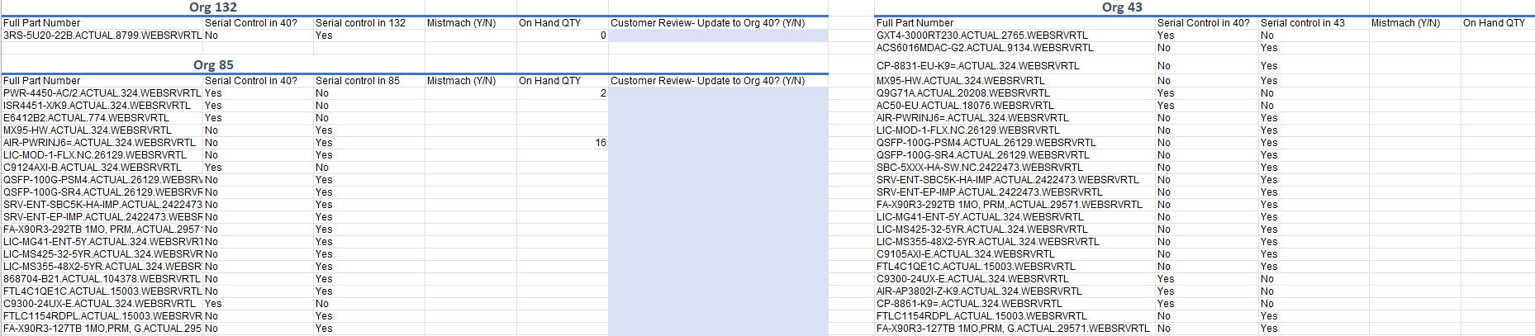

* 1. Comparison Between Non-Hardware Parts as Vertex and Serial Control

With the report generated in step 1, check the comparison between non-hardware parts as vertex and serial control. Items that are not hardware should not have serial control turned on. Create a list of items that are not hardware but have serial control to send to the customer for review.

1. **Org Mismatches Audit**

With the report generated in step 1, check which items are not created in the specific org according to program requirements.

Use this information to prepare and drop an FTP upload to associate new orgs to existing Oracle items using the Item Org Assignment Upload Template and drop the file in the ItemOrgAssignment Folder in the FTP Site.

Pull the following information from the report in step 1:

Full part number

Organization code (ONLY ORG 01)

Description

Compare vertex/UNSPSC and description, and update if there are any mistakes in the vertex.

Record the total number of items where the vertex has been updated and add it to the summary audit.

1. **Other Attributes**

8.1 Customer ID (ONLY FOR Charter, Cox Comm, CoxRev FCBK, ORCL). This attribute has to be checked in all orgs.

Customer (child org attribute) Only for FCBK, COX COMM, COXREV

Do the same comparison between orgs as in step 2.1

8.2 Cross Reference. This attribute only has to be checked in org 01.

(ONLY FOR ORCL)

Oracle MKTG Part

Oracle Vendor Number

Categories (Ascenc